Responsive Web Design

Definition
# Source: AI Source: Provided by: [Data Path: Persons Table -> ID Column: 1, Name_En Column: Motasem Essam] -> From: [Chatgpt (GPT‑5 Mini)] on [2/12/2026]
Responsive Web Design is a web design technique that makes a website automatically adjust its layout and content to fit different screen sizes, such as mobile phones, tablets, and desktop computers.

Simple Definition
# Source: AI Source: Provided by: [Data Path: Persons Table -> ID Column: 1, Name_En Column: Motasem Essam] -> From: [Chatgpt (GPT‑5 Mini)] on [2/12/2026]
Responsive Web Design = a design that changes its layout to look good on any device.

How Responsive Web Design Works
# Source: AI Source: Provided by: [Data Path: Persons Table -> ID Column: 1, Name_En Column: Motasem Essam] -> From: [Chatgpt (GPT‑5 Mini)] on [2/12/2026]
• Uses flexible layouts (like percentages instead of fixed sizes)
• Uses media queries in CSS to apply different styles for different screen sizes
• Uses flexible images that resize automatically
• Adjusts navigation, text, and elements based on screen width

Purpose of Responsive Web Design
# Source: AI Source: Provided by: [Data Path: Persons Table -> ID Column: 1, Name_En Column: Motasem Essam] -> From: [Chatgpt (GPT‑5 Mini)] on [2/12/2026]
• Provide a good user experience on all devices
• Make websites mobile-friendly
• Improve readability and usability
• Avoid creating separate websites for each device
• Improve SEO (search engine ranking)

Advantages
# Source: AI Source: Provided by: [Data Path: Persons Table -> ID Column: 1, Name_En Column: Motasem Essam] -> From: [Chatgpt (GPT‑5 Mini)] on [2/12/2026]
• Works on all devices (mobile, tablet, desktop)
• Better user experience
• Faster development (one website instead of many)
• Improves accessibility

Disadvantages
# Source: AI Source: Provided by: [Data Path: Persons Table -> ID Column: 1, Name_En Column: Motasem Essam] -> From: [Chatgpt (GPT‑5 Mini)] on [2/12/2026]
• Can be complex and time-consuming to design and develop
• Requires careful planning and testing across many devices
• May increase development time and cost
• Can lead to slower performance if not optimized properly
• Difficult to maintain complex layouts across all screen sizes
• May require more CSS and code, increasing file size

Examples
# Source: AI Source: Provided by: [Data Path: Persons Table -> ID Column: 1, Name_En Column: Motasem Essam] -> From: [Chatgpt (GPT‑5 Mini)] on [2/12/2026]
• A website that changes from a multi-column layout on desktop to a single-column layout on mobile
• Navigation menu turning into a hamburger menu on small screens
• Images resizing automatically to fit the screen

Difference Between Responsive Web Design and Other Techniques
# Source: AI Source: Provided by: [Data Path: Persons Table -> ID Column: 1, Name_En Column: Motasem Essam] -> From: [Chatgpt (GPT‑5 Mini)] on [2/12/2026]
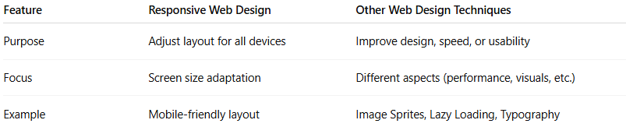
Feature | Responsive Web Design | Other Web Design Techniques
Purpose | Adjust layout for all devices | Improve design, speed, or usability
Focus | Screen size adaptation | Different aspects (performance, visuals, etc.)
Example | Mobile-friendly layout | Image Sprites, Lazy Loading, Typography

